ПЛАН УРОКА
Предмет | Английский язык | 
Учитель | Ахметова М.У.
Школа, класс | г. Кызылорда, КГУ «СШ №211 им. А. Байтурсынова», 3 класс
Тема урока | Days of the week

Learning objective(s) that this lesson is contributing to: | To name the days of the week; to write the dates; to say the ordinal numbers.  To get information from the text.
Lesson objectives | All learners will be able to:
Lesson objectives | - 3.R1 read and spell out words for others;  - 3.UE2 use cardinal and ordinal numbers 1 -50 to count;  - 3.L1 understand a range of short basic supported classroom instructions.  Most of the learners will be able to:  - 3.R6 understand with considerable and particularly visual support, some specific information in short, simple texts on familiar topics.  - 3.L4 recognize with support short basic questions relating to features such as colour and number.  Some learners will be able to:  - 3.S2 ask questions in order to satisfy basic needs and find information on familiar topics and classroom routines  - 3.S6 use short answers appropriately in short, basic exchanges and take turns when speaking with others in a limited range of short, basic exchanges.  - 3.W1 write with support short responses at phrase level to questions and other prompts.
Assessment criteria: | Learners have met the learning objectives if they can: name the days of the week; describe daily routine; say the ordinal numbers; write the dates.
Language focus: | Structures: present simple.  Language in use: What day is it today? It’s Monday.  How many hours? How many minutes? It’s ten o’clock.
Target vocabulary: | Days: Monday, Tuesday, Wednesday, Thursday, Friday, Saturday, Sunday; Ordinal numbers; Teatime, drink hot tea.
ICT skills: | Using audios and videos from bilimland.kz 
Extra materials: | Posters with the holidays in December: 1st of December – Day of the First President of RK, 16th of December – Independence Day, 31st of December – New Year.  Posters with the math problems, Worksheets.
Previous learning: | «Time» vocabulary.

Plan
Planned timings | Planned activities (replace the notes below with your planned activities) | Smiles Resources
BEGINNING THE LESSON  3.UE2  3.L1 | Ss make a circle and sing a song «Hello»  Teacher asks them to count 1-50. Then she asks Ss to divide into two groups: even numbers and uneven numbers.    Even numbers-Group 1 Uneven numbers-Group 2 | «Hello» song for kids  https://www.youtube.com/watch?v=gghDRJVxFxU
PRESENTATION AND PRACTICE  3.R6  3.S6  3.W1  3.UE2  3.L1  3.L4  Link with other subject:  History  3.W1  Link with other subject:  mathematics  3.S6  3.L1 | T brings the letters: E T M I and asks the Ss to make the word. Ss guess the word, it is TIME!  This is the theme of our lesson! Very good!  Group Work  Read the text, retell it for the other group, and do the task.    T gives two flags for each group:  Great Britain and Kazakhstan   T: Why I’m giving you the flag of Great Britain?  Ss: Because we are learning English!  T: Yes! You are so clever! First, listen to the text, please.  (Ss listen to the text, then repeat the new words from it)  Now, group 1 will read the text about Kazakhstan, and group 2 will read the text about Great Britain, OK?  Text: «Teatime» Text1: «Teatime in Great Britain»  People in the UK love drinking tea.  Teatime is usually the best time of the day.  Traditionally teatime is at about four or five  o’clock in the afternoon.  People drink hot tea with milk or sugar and eat  cakes or sandwiches.  Many people drink tea all the day- from  breakfast till the bedtime.  Vocabulary  Teatime – шәй уақыты  Breakfast – таңғы ас  Bedtime – Ұйқы уақыты  Drink hot tea – ыстық шәй ішу  Traditionally – дәстүр бойынша  Read and complete:  1. People in the UK love ___________ .  2. Traditionally teatime is at about ______ or ______ o’clock.  3. People drink tea with ___________ .  Text2: «Teatime in Kazakhstan»  Teatime in Kazakhstan is a big part of the day. Kazakh people like drinking black tea with milk a lot.  They drink tea from teacups called kesse.  When you visit Kazakhstan, there is always hot tea for you!  Vocabulary  Teatime – шәй уақыты  Teacups – чашкалар  Visit – қонаққа бару  Hot tea – ыстық шәй  Drink black tea – қара шәй ішу  Read and complete:  - Kazakh people like ___________ with _________ .  - They drink tea from teacups called _________ .  - When you visit Kazakhstan, there is always  ___________ for you!  Feedback  Ss assess to each other.  Groups rise their thumbs.    - Listen, point and repeat.  Pupils’ books closed. Teacher: What day is it today? I know you can count 1–100. But do you know the ordinal numbers?  Let’s say altogether! The pupils repeat, chorally and individually.  1 one – first 6 six – sixth  2 two – second 7 seven – seventh  3 three – third 8 eight – eighth  4 four – fourth 9 nine – ninth  5 five – fifth 10 ten – tenth  Individual work  T: You should work individually. These are pencils for you.  Ss are given worksheets with the task. Read and colour the presents.  The first present is green.  The fifth present is blue.  The fourth present is brown.  The second present is red.  The third present is purple  (Each pupil works individually.)  Feedback  Ss swap their papers and check the task.  The key are highlighted on the board.  Pair work  T: We need ordinal numbers to say the dates, yes?  What kind of holidays do you know on December?  Look at these posters:  The 1st of December – Day of the first President of the RK  The 16th of December – Independence Day  The 31st of December – New Year  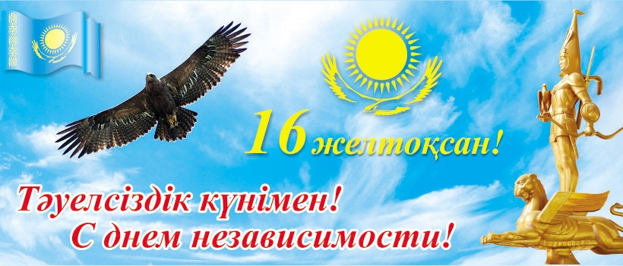  These are the main holidays of the year.  Task: Write the dates  Ss are given worksheets.    8 наурыз  9 мамыр  1 қыркүйек  Pupils work in pairs. They write the dates using ordinal numbers.  Example: The 8th of March. The 9th of May.  The 1st of September.  Feedback  Pupils check themselves. Suggested key highlighted on the board.  T: Our theme today is TIME, so, you should know from your mathematics lesson, about it. Look at the board:  1 Hour = 60 minutes  1 minute = 60 seconds  Ok, let’s check how well you know it.  Warm up.  Now, let’s play game. I’ll read you the sum, you should answer. Who will be faster?  - Beric plays the guitar for two hours every day.How many hours does he play in a week? /2x7=14 hours/  - Sanzhar has a shower for 5 minutes every morning.How many minutes does he have a shower in a week? /5x7=35 minutes/  - Damir goes fishing with his dad on Sundays.Today he is fishing 90 minutes. How many hours is he fishing?/half past one hours/  Pupils solve the math problems very well.  T:You are so clever, boys and girls!  Speech time  - Talk with your friend.  In pairs, the pupils ask and answer questions, as in the example. Ask a few pairs to report back to the class.  P1: What day is it today?  P2: It’s Monday.  So pupils revise the week days.  Individual work  Pupils do exercise from their work-books.  Unscramble the words.  Example: dywnsaen – Wednesday  Feedback  Suggested key highlighted on the board. Selfcheck. | There is a text highlighted on the whiteboard: «Teatime»  Groups are given sheets with the text and vocabulary.    Bilimland.kz  Year 3  17. Nine or Nineteen?  https://bilimland.kz/ru/courses/english-language/core-curriculum-for-english/year-3/lesson/017-nine-or-nineteen  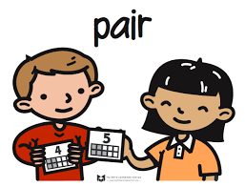  Bilimland.kz  Year 3  15 It’s ten o’clock  https://bilimland.kz/ru/courses/english-language/core-curriculum-for-english/year-3/lesson/015-it-s-ten-o-clock  Bilimland.kz  Year 3  007.Today is Monday  https://bilimland.kz/ru/courses/english-language/core-curriculum-for-english/year-3/lesson/007-today-is-monday
END of the lesson  3.R1  3.L1 | Can you spell the words?  T: Let’s watch the video. Can you spell the days of the week?  M-O-N-D-A-Y, T-U-E-S-D-A-Y, W-E-D-N-E-S-D-A-Y,  T-H-U-R-S-D-A-Y,F-R-I-D-A-Y,S-A-T-U-R-D-A-Y,S-U-N-D-A-Y  Pupils read and spell the words very well.  ACTIVITY BOOK (Optional)  If you wish, you can assign some or all of the corresponding exercises from the Activity Book for homework. If this is the case, make sure you explain them first in class. | Bilimland.kz  Year 3  012.I can Spell the Days  https://bilimland.kz/ru/courses/english-language/core-curriculum-for-english/year-3/lesson/012-i-can-spell-the-days

Additional information
Differentiation – how do you plan to give more support? How do you plan to challenge the more able learners? | Assessment – how are you planning to check learners’ learning? | Cross-curricular links  Health and safety check  ICT links  Values links
- I’ve prepared guidelines  - Worksheets with topical vocabulary  - Posters on the board | As marks I prepare such helpers for you:  Excellent! – rocket (You are Clever! - written there)    Good job!- train (Days of the week are written on it)    Not bad – bus (1 hour – 60 minutes – 1 minute – 60 seconds)   | Link with other subject:  - mathematics  - history  - Russian  - music
Reflection  Were the lesson objectives/learning objectives realistic?  Did I stick to timings?  What changes did I make from my plan and why? | Use the space below to reflect on your lesson. Answer the most relevant questions from the box on the left about your lesson

