ПЛАН УРОКА
Предмет | Английский язык | 
Учитель | Мустафина Л.Б.
Школа, класс | Карагандинская обл., Нуринский район, с. Заречное, КГУ «Заречная ОШ», 7 класс
Тема урока | How to get fit

Learning objectives(s): | 7.1.1.1 use speaking and listening skills to solve problems creatively and cooperatively in groups.  7.2.3.1 understand with some support most of the detail of an argument in extended talk on a limited range of general and curricular topics.  7.3.5.1 keep interaction with peers to negotiate, agree and organize priorities and plans for completing classroom tasks.  7.4.5.1 deduce meaning from context in short texts on a growing range of familiar general and curricular topics.
Lesson objectives: | All learners will be able to:  - Revise topical vocabulary.  - Study new topical vocabulary.  Most learners will be able to:  - Use new vocabulary at sentence level.  - Search for appropriate using resourses and research a given problem.  Some learners will be able to:  - Evaluate their classmates.  - Express their thoughts, ideas and experiences, supporting them with arguments.
Language objective: | To use new active vocabulary and correct grammar constructions in their speech.
Value links: | Healthy Life Responsibility.
Cross curricular links: | Biology.
Use of ICT: | Smart Board and projector to present the material, computers.

Planned timings | Planned activities | Resources
Beginning  1 min.  3 min.  3 min.  Pre-learning  2 min.  Presentation.  3 min.  5 min.  2 min.  10 min.  3 min.  3 min  2 min.  2 min.  1 min. | Greeting. Good morning! I am glad to see you! How are you today? I hope you are healthy and fine! Let's start our lesson with the warm-up!  Warm-up activity.  Teacher asks learners and discuss the following questions:  What sports do you do? What's your favourite sport?  Checking up the homework.  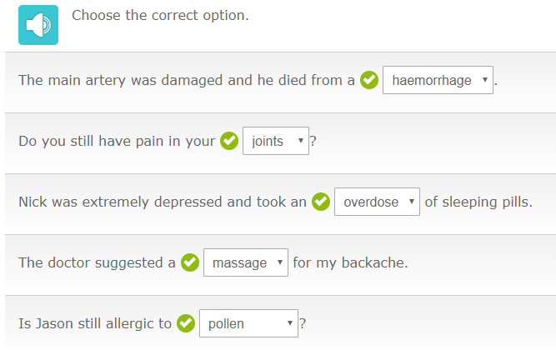  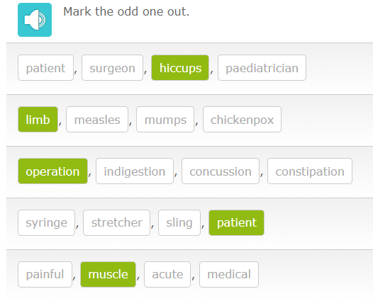  Criteria of tasks: 1 right answer - 1 point  Total: 10  New material.  Learners should guess the topic of the lesson by looking at the pictures.    Learners discuss and share ideas and come up with lesson topic. The students predict the objectives of the lesson.  Introduction of new vocabulary.  Students watch a presentation of the words on the topic and repeat the new words after the speaker/ teacher gives students handouts with the words to remember.  • Muscle strength  • Stamina  • Flexibility  • Agility  • Speed  • Cardiovascular efficiency  •Aerobic respiration  • Anaerobic respiration  • Lactic acid  • Equation  Watching the film «What is fitness?»  Students answer the questions:  - How many core indicators of fitness are there?  - What are they?  Grouping.  Learners are divided into three groups with the help of pictures.  Project work.  Group 1 – «The physically fit»  Group 2 – «The body during exercise»  Group 3 – «Improving of fitness»  1) to make poster  2) to present the project  3) to give points to each other using criteria  Listening practice.  Task 1. Learners read and choose the correct option.  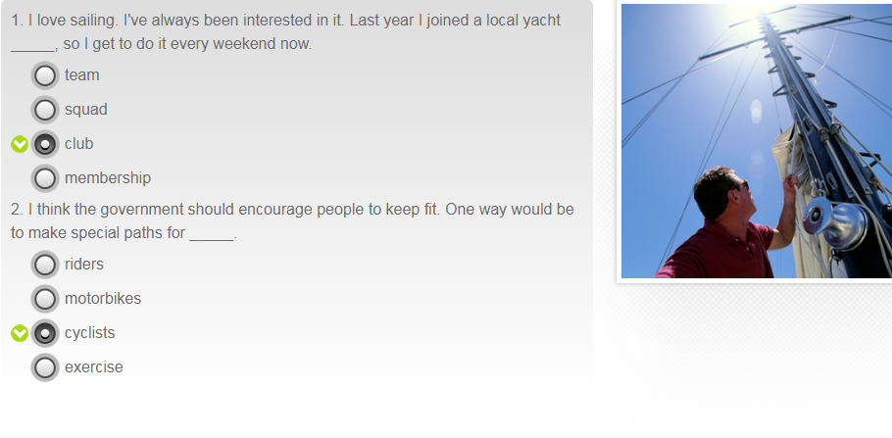  Task 2. Learners listen to the recording «Sport and safety» and choose the correct option.  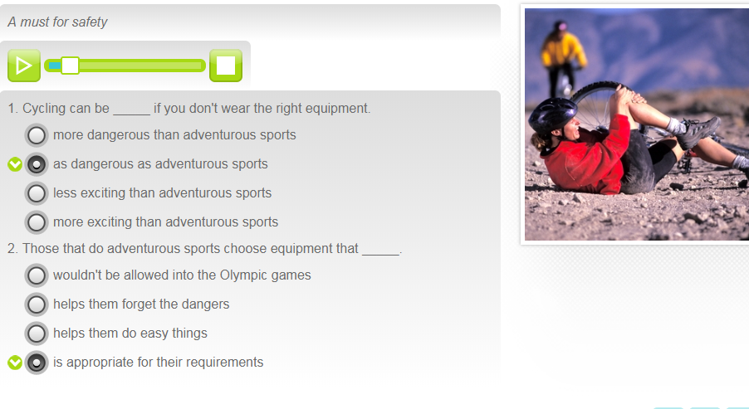  Criteria of tasks: 1 right answer - 1 point  Total: 4  Test.  Learners answer the questions showing the cards with the letters A, B, C or D.  1.  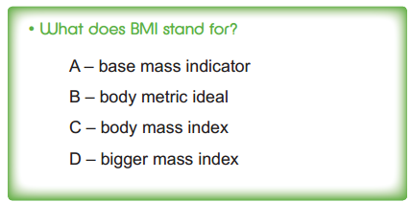  2.  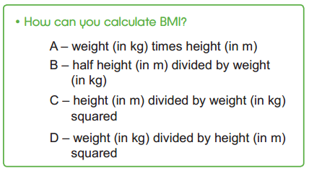  3.  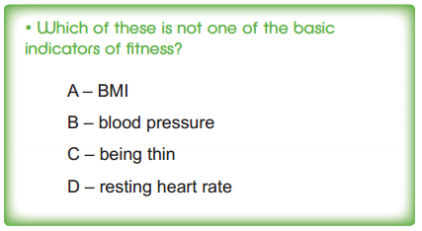  4.  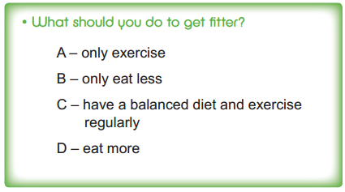  5.  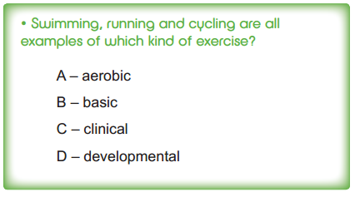  6.  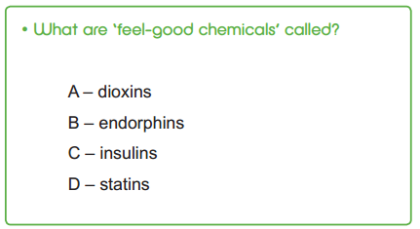  Criteria of tasks: 1 right answer – 1 point  Total: 6  Assessment.  Learners count points and tell teacher.  Individual sheet  Success criteria:  21-24 points – high level  16-20 points – mid level  Reflection.  At the end of the lesson, students reflect on their learning.  - What has been learned today?  - What remained unclear?  - What is necessary to work on?  Home task:  To write a cinquain poem «Fitness». |   https://bilimland.kz/ru/courses/english-language/mskills-english/intermediate-level-vocabulary/lesson/011-medicine  Tasks 19-20  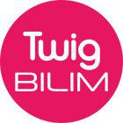  https://twig-bilim.kz/ru/film/what-is-fitness  PPT  https://twig-bilim.kz/ru/film/what-is-fitness  https://twig-bilim.kz/ru/film/what-is-fitness  - Education materials.  https://bilimland.kz/ru/courses/english-language/mskills-english/intermediate-level-listening/lesson/018-sport-and-safety  Task 1,2  - Twig_fitness  Quiz, PPT
  Criteria | Point
  1. Content | 1
  2. Using of vocabulary | 1
  3. Grammar | 1
  4. Pronunciation | 1
  Tasks | Max point | My point
  1. Homework | 10
  2. Project | 4
  3. Listening | 4
  4. Test | 6
  Total | 24

